

DCM Glasgow Coma Scale
Draft v 0.75

Contents
1. Glasgow Coma Scale (org.hl7.GlasgowComaScale(15pointversion)-v0.75) 3
1.1 Revision History 5
1.2 Concept 5
1.3 Mindmap 5
1.4 Purpose 5
1.5 Patient Population 5
1.6 Evidence Base 5
1.7 Information Model 6
1.8 Example Instances 11
1.9 Instructions 12
1.10 Interpretation guidelines 13
1.11 Care Process 13
1.12 Example of the Instrument 13
1.13 Constraints 13
1.14 Issues 13
1.15 Referenties (References) 14
1.16 Functional Model 15
1.17 Traceability to other Standards 16
1.18 Disclaimer 17
1.19 Terms of Use 17
1.20 Copyrights 17

Glasgow Coma Scale (org.hl7.GlasgowComaScale(15pointversion)-v0.75)
DCM::Author.Coding
DCM::Author.Model | Michael van der Zel
DCM::Author.Review | OLVG nursing team, Marit Verweij, HL7 ballot respondents.
DCM::ContactInformation.Name | Results 4 Care BV, Amersfoort, the Netherlands.
DCM::ContactInformation.Telecom | DCMHelpdesk@results4care.eu
DCM::ContentAuthorList | Drs. A.T.M. Goossen,Dr. W.T.F. Goossen,Drs. Y.J. Koster-de Jong. Results 4 Care.
DCM::CreationDate | 29-Jan-2014
DCM::DescriptionLanguage | en
DCM::EndorsingAuthority
DCM::ExpirationDate
DCM::FileType | UML/XMI
DCM::Id | DCMR4C3
DCM::KeywordList | Glasgow Coma Scale D015600, level of consciousness
DCM::Language | en,nl
DCM::LifecycleStatus | Final
DCM::Name | org.hl7.GlasgowComaScale(15pointversion)
DCM::PublicationDate | 2010-jul-09
DCM::PublicationStatus | after HL7 DCM ballot R1
DCM::RepositoryId
DCM::RepositoryURL
DCM::SupportingOrganisation | OLVG, Amsterdam and Nictiz, The Hague, earlier versions of GCS for trauma and stroke projects
DCM::Type | Observation
DCM::Version | 0.75

Revision History
Version 0.66c added cardinalities for Items, one could only record TotalScore
Version 0.67 - 0.69 in between work with minor changes
Version 0.70 The full change request for HL7 DCM ballot have been handled and OLVG EMV scoring work has been carried out.
version 0.74 is based on a final review, in particular based on Teasdale and Murray, 2000.
version 0.75 is double checked for the HL7 DCM ballot of 2010 ballot comments, and parts of the NFU work in 2013 have been included. The pediatric scale is kept apart from this adult scale.

Concept
The Glasgow Coma Scale, also called the EMV score (best Eye, best Motor, and best Verbal response), is an assessment scale for the assessment of the level of consciousness of a patient (NVICV, 2010). This model holds the original 15 point version of the GCS.
Other instruments exist but will not be described here.

Mindmap

Purpose
To record and monitor the level of consciousness of a patient (NVICV, 2008). Measuring the level of consciousness is important for the diagnoses, the prognosis, and the follow-up of the neurological condition of the patient.

Patient Population
Monitoring patients (NVICV, 2010):
- after intracranial surgery
- in case of neurological disorders (CVA, encephalitis, meningitis)
- the level of consciousness with trauma patients
- after intoxication with substances which can influence the level of consciousness

The GCS is not applicable with children. For children there is the Pediatric Glasgow Coma Scale (PGCS). That is usually applied to children < 17 year. There is a separate DCM required for Pediatric GCS.

Evidence Base
The Glasgow Coma Scale (GCS) was developed to record and monitor the level of consciousness of patients with a lowered consciousness because of brain injury, such as coma, conscious patient with a blow to the head, head trauma, or post seizure etc. This is done via assessing the patients best eye, best vocal and best motor response (EMV). Measuring the level of consciousness is important for the diagnoses, the prognosis and for follow-up of the condition of the patient. The latter to be able to detect a further drop of consciousness, on time, so action can be taken.

There are separate directions of use of the GCS for adults and children. This DCM describes the use of the GCS for adults. A separate Pediatric Glasgow Coma Scale (PGCS) has been adapted for children. This is described in a separate DCM.

The GCS can be used in two manners: one is the original total score. However, in some practices the EMV score is presented. That is a simple summation of the three individual scores for Eye, Motor and Verbal (EMV), without doing the calculation into a total score. This is the preferred method according to Teoh (2000).

The developers first reported the use of the GCS to record coma after head trauma (Teasdale en Jennett, 1974). The Glasgow Coma Scale is an internationally accepted scale which gives a good estimate of the severity of the brain injury.

All abstract words with which a drop of consciousness can be described (the value sets for each of the scores) is actually a ‘translation’ of what one can observe with the patient, this means what the patient does, spontaneous or after stimulation. The benefit of the Glasgow Coma Scale is that this scale only reflects what the patient does, in simple terms (Bruining, Lauwers & Thijs, 1991). Moreover the psychometric traits of the instruments have been analysed, among others based on Wade (1994).

In their 2000 paper Teasdale and Murray (2000) plea to stick to the original GCS which implies 6 items for motor, counting a total score with range 3 to 15 and also document the individual scores for each item and to indicate if each of the three variables could be measured or not.

Information Model
This section about the information model includes first a small description of the model components. Next, a representation of the model in Unified Modeling Language is given. Then the single data elements, as represented in each of the classes, is defined in the table format.
Each data element will be defined, its data type specified, using a subset of ISO 21090, and using a unique code from one or more standardized terminologies. Where applicable a value set will be enumerated and coded.

GlasgowComaScale has TotalScore
TotalScore is a number
GlasgowComaScale has Items
Items has V=Verbal reaction
Items has M=Best motor response
Items has E=Eye opening
V=Verbal reaction is a coded ordinal (CO)
M=Best motor response is a coded ordinal (CO)
E=Eye opening is a coded ordinal (CO)

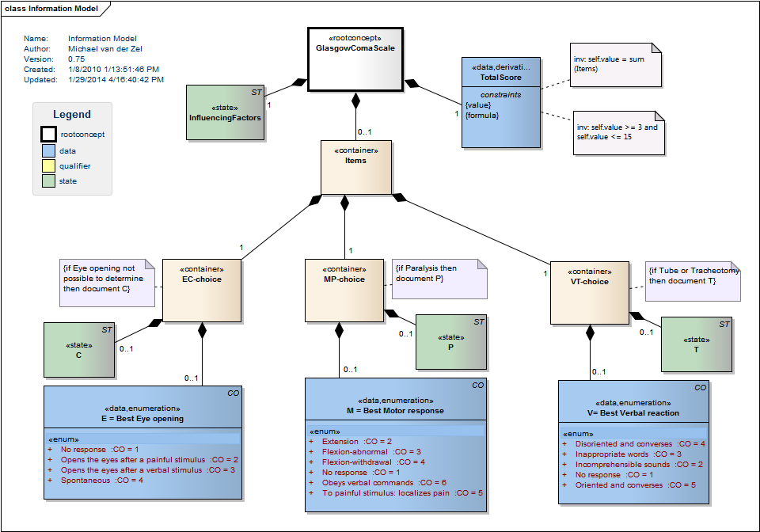

Concept | Definitie
GlasgowComaScale  SCT: 386554004: Glasgow coma scale (assessment scale) | The Glasgow Coma Scale, also called the EMV score, is an assessment scale for the assessment of the level of consciousness (NVICV, 2010).

Concept | Definitie
InfluencingFactors  R4C: DCMGCS8765 | Allows to comment on circumstances during assessment.

Concept | Definitie
TotalScore  SnomedCT:code 386560004: Glasgow coma score (Type:= clinical finding); LOINC: 9269-2 Glasgow Score Total , LOINC: code displayName, LOINC: 9269-2 Glasgow Score Total, SCT:: 386560004: Glasgow coma score (Type:= clinical finding) | The total score on the Glasgow coma scale
Constraint | value | inv: self.value >= 6 and self.value <= 24
Constraint | formula | inv: self.value = sum(*)

Concept | Definitie
Items | Modeling mechanism to combine all sub scores to one total score.

Concept | Definitie
EC-choice | Allows to express either the score or the comments or both.

Concept | Definitie
E = Best Eye opening  SCT: 281395000: GCS eye opening subscore, LOINC: 9267-6 Glasgow Score Eye Opening | The patient's best eye response.
  No response  LOINC: LA6553 No eye opening | Doesn’t open the eyes not even after a stimulus.
  Opens the eyes after a painful stimulus  LOINC: LA6554 Eye opening to pain | Opens the eyes after a painful stimulus. Such as a central painful stimuli (suborbital) or a peripheral painful stimulus (nail bed).
  Opens the eyes after a verbal stimulus  LOINC: LA6555 Eye opening to verbal command | Opens the eyes after a verbal stimuli, this can be normal, repeated or even loud.
  Spontaneous  LOINC: LA6556 Eyes open spontaneously | Opens the eyes spontaneously.

Concept | Definitie
C  R4C: DCMR4C3-1 | Comments to Eye opening

Concept | Definitie
MP-choice | Allows to express either the score or the comments or both.

Concept | Definitie
M = Best Motor response  LOINC: 9268-4 Glasgow Score Motor, SCT: 281396004: GCS motor response subscore | The patient's best gross motor response.  Points of interest:  Ø Consider that the reaction of the legs can be a spinal reflex.  Ø Test both arms and score the best reaction of both;  Ø Don’t give a painful stimuli to an injured part of the body; choose in that case another body part.
  Extension  LOINC: LA6563 Extension to pain | Extension to painful stimuli (decerebrate response).  Extension, adductive and internal rotation: of the upper and lower extremities.
  Flexion-abnormal  LOINC: LA6564 Flexion to pain | Abnormal flexion to painful stimuli (decorticate response). As in abnormal flexion: of the arms, this goes with extension of the legs and the flexion backwards of the feet.
  Flexion-withdrawal  LOINC: LA6565 Withdrawl from pain | Flexion / Withdrawal to painful stimuli . Withdrawal to painful stimuli: avoid pain or stretched out the arm towards painful stimuli but cannot localize the source of the pain or withdraws from it.
  No response  LOINC: LA6562 No motor response | No response to painful stimuli. Not even to painful stimuli.
  Obeys verbal commands  LOINC: LA6567 Obeys commands | Obeys to verbal verbal commands: does carry out commands even in a weak state.
  To painful stimulus: localizes pain  LOINC: LA6566 Localising pain | Localizes to pain: purposeful movements towards painful stimuli.  Tries to withdraw from the pain.

Concept | Definitie
P  R4C: DCMR4C3-2 | Allows to indicate whether paralysis is present.

Concept | Definitie
VT-choice | Allows to express either the score or the comments or both.

Concept | Definitie
V= Best Verbal reaction  LOINC: 9270-0 Glasgow Score Verbal, SCT: 281397008: GCS verbal response subscore
  Disoriented and converses  LOINC: LA6560 Confused | Speaks but is confused or disoriented: confused to one or more of the following: time, place or person, the ability to perform a conversation. Use inappropriate words in response to questions.
  Inappropriate words  LOINC LA6559 Inappropriate words | Utters words inappropriate to the question or setting  and that have no or limited coherence, words are used ad random, yelling or cursing.
  Incomprehensible sounds  LOINC LA6558 Incomprehensible sounds | Makes incomprehensible sounds (growling /groaning).
  No response  LOINC LA6557 No verbal response | Makes no sound, doesn’t speak.
  Oriented and converses  LOINC: LA6561 Oriented | Oriented, converses normally. Obeys verbal commands

Concept | Definitie
T  R4C: DCMR4C3-3 | Indicator for Tube.

Example Instances

Instructions
The Glasgow Coma Scale comprises three component scores: eye opening, best motor response and best verbal response. The GCS consists of observing the responses of the patient to stimuli. The GCS is scored by writing down/entering the number of the best response observed with the patient, if necessary after a painful stimulus.
The GCS is always recorded in the Landelijke Trauma Registratie (the Dutch National Trauma Registration) even when the patient has a tube. Then a verbal score, and therefore the total score, is always lower than could be when the patient did not have a tube, because having a tube makes speaking impossible.

If the patient has a tube a verbal score is difficult. Similar limitations exist in the case the patient is Paralyzed, or has Eye disabilities. Van der Naalt (2004) advises pseudo codes in this case in order to not loose information. The value can be influenced by qualifiers indicating how the total score should be interpreted. A qualifier is documented which can have one or more of the following possibilities:
* Paralyzed (P) (PARAL)
* Tube (T) (TUBE)
* Paralyzed & Tube (P&T)
* C (for the disability for Eye)

Other factors that are of influence on the scores are (TVPO, 2004):
- Sedatives;
- Inadequate ventilation/respiration;
- A core body temperature of less than 33 degrees Celsius;
- Severe metabolic dysfunction.

The reliability of the score decreases when one or more of these factors are present.

Points of interest
- There are situations in which the criterion for opening the eyes can not be used as an indication for the level of consciousness. When a person wants to open his eyes but is physically unable to, or when a person is deaf and can not hear the request for opening the eyes (Gelmers, 2002), for example. Then this item should be marked with a C.
- A painful stimulus can only be applied through the nail bed. Other stimuli can not be taken into account.
- Problems Verbal response: patients who have aphasia or do not speak the language well enough testing the verbal response. Patients with a tube or tracheotomy also cause problems when recording the score; for these patients one can not score ‘no response’, but one should score a ‘T’.
- A painful stimuli isn’t used with patients who are sedated or has a body temperature of <33 degree Celsius. The control of the reaction of the pupils is advised and this item should be marked with a C.
- The sum score is being indicated without the items for which a T or C or Paralysis has been scored. The total of the score will then be lower. This can be recovered from the qualifier.

The GSC is recorded in the patient record. When the GCS is suddenly changed, especially when the condition of the patient decreases, the doctor must be warned (TVPO, 2004).

Interpretation guidelines
The adding of the scores on three different components make the total Glasgow Coma Scale Score. In a total score of 8 or lower (£ 8 out of 15) (Meijer, 2004, submitted) there is severe trauma; the patient is in a coma. A score of 13 to 15 indicates moderate brain damage. And in a total score of 13 to 15 there is light brain damage.
Besides the total Glasgow Coma Scale score the EMV-score can also be given. This represents the best performance of the three different reaction patterns. A normal oriented patient that is awake has an EMV score of 4-6-5 also noted as E4M6V5. In terms of the EMV score a coma is indicated by an EMV of 1-5-2 (or E1M5V2) or lower (Gelmers, 2002). For further interpretations of scores that are in between reference is done to the literature.

Care Process

Example of the Instrument
The Glasgow Coma Scale is a total score and will be presented as a total score. In the Netherlands also the EMV Score is used. This is a presentation of the scores on the Eye opening, Best Motor response and the Verbal reaction. The score is represented as ' 2 3 4' or ' E2M3V4' .

In the enumeration is also a possibility to score 0. This stands for C Not possible to determine with the Eye opening, P Paralysis with Best Motor response and T with Verbal reaction. In the representation of the Glasgow Coma scale the C, P and T must be represented instead of 0

Example from de Bel, (2013).
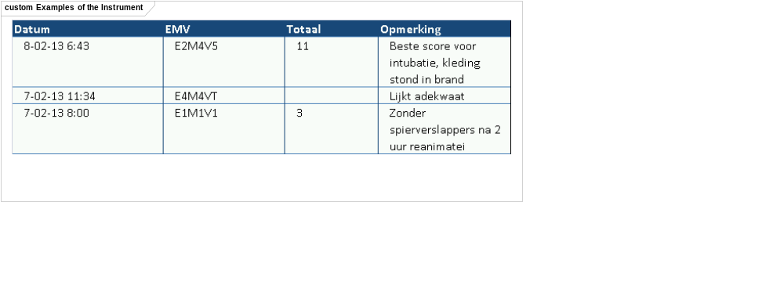

Constraints
Total score is minimal 3 and maximal 15 points.

Issues
The Glasgow Coma Scale is copyrighted. However, informants for this DCM could not indicate who is the copyright holder. Any information about this would be appreciated.

There is debate if the letter scores may or may not be used in the model. It is one of a value set, hence allow to not implement the letters.

Referenties (References)
Projects:
Developed as a Careinformationmodel for the following projects:
- NICTIZ CVA Ketenzorg (Continuity of care for patients with CVA)
- Nictiz Traumazorg (Trauma care)
- ACTIZ Eenheid van taal (Uniformity of language)
- Parelsnoer initiative
- OLVG nursing record

Literature:
- Archetype openEHR-EHR-OBSERVATION.glasgow_coma.v1draft. Obtained on 26 augustus 2008, from http://www.openEHR.org.
- Bruining, H.A., Lauwers, P., Thijs, L.G. (1991). Intensive care. Utrecht, Wetenschappelijke uitgeverij Bunge.
- Care informationmodel Doc_Obs_Glasgow_Coma_Scale_R01_V1.1.doc. Obtained on 26 augustus 2008, from http://www.zorginformatiemodel.nl.
- CCR. Standard Specification for Continuity of Care Record (CCR), E 2369 – 05, ASTM, 2010.
- Casus 24L Fase A. Neurogene shock door dwarslaesie niveau C8. Obtained on 26 augustus 2008, from http://www.lumc.nl/5030/deliverables/documenten/Casus%2024L%20Fase%20A.pdf (Leids Universitair Medisch Centrum).
- De Bel E (2013). Klinische bouwsteen Glasgow Coma Scale. Den Haag, Nictiz en Utrecht, NFU.
- De Jong, T. (2005). Model D-MIM voor de traumaregistratie. Leidschendam, NICTIZ.
- Gelmers, H.J. (2002). Neurologie voor verpleegkundigen. Assen, Koninklijke Van Gorkum.
- Glasgow Coma Scale (GCS). Obtained on 18 Febraury 2010, from http://www.nvicv.nl (Nederlandse Vereniging van IC Verpleegkundigen).
- Het Kwaliteitsinstituut voor de gezondheidszorg: CBO. (2002). Herziening consensus ernstig traumatisch hersenletsel. Utrecht, CBO.
- Glasgow Coma Score. Obtained on 26 augustus, from http://www.ssgfx.com/CP2020/medtech/glossary/glasgow.htm
- Meijer R Limbeek van J Haan de RJ (2004). Development of the Stroke-unit Discharge Guideline. Choice of assessment instruments for prediction in the subacute phase post-stroke. Submitted.
- Matis, B, Birbilis, T: “The Glascow Coma Scale- a brief review. Past, present, future”. Acta Neurol Belg, 2008 sep; 108(3):75-89.
- Naalt van der, J: “Fysische diagnostiek- de Glasgow Coma Scale voor het meten van bewustzijnsstoornissen”.Nederlands Tijdschrift voor Geneeskunde, 2004; 148 (10).
- Tabellenboekje. http://www.tabellenboekje.nl/menselijk-lichaam-tabel-glasgow-coma-schaal.php#glasgow-coma-schaal-volwassen
- Teasdale G, Jennett B. (1974). Assessment of coma and impaired consciousness. A practical scale. Lancet. 1974 Jul 13;2(7872):81-4.
- G. M. Teasdale and L. Murray. Revisiting the Glasgow Coma Scale and Coma Score. Intensive Care Med vol. 26, no. 2, pages 153-154 (Feb. 2000).
- Transferpunt VaardigheidsOnderwijs, (2004). Vitale functies en reanimatie. Werkcahier niveau 4. Houten, Bohn Stafleu Van Loghum.
- Villaneuva, Nancy. E., Bell, Linda. (1993). Neurosurgiacal Critical Care Nursing: Head Injury. In Jonathan Greenberg (Ed.). Handbook of Head and Spine Trauma (pp 341-349), New York: Marcel Dekker.
- Wade DT. (1984). Measurement in neurological rehabilitation. Oxford, Oxford medical publications.

Vocabulary:
SNOMED CT OID: 16.840.1.113883.6.96

LOINC OID: 2.16.840.113883.6.1

For the use of Snomed CT in a system and/or Healthcare organisation, a licence is for Snomed CT is needed. More information about a licence in the Netherlands you can find on the website of Nictiz www.nictiz.nl

Functional Model
This DCM would fit in the HL7 Electronic Health Record System Functional Model at the following location:

Concept | Definitie
DC.2.1.1 Support for Standard Assessments

Traceability to other Standards
This can be part of the HL7 CCD.

--DCM::Language=nl
Voor deze DCM zijn enkele onderdelen uit de klinische bouwsteen van NFU overgenomen. Daarin is aangegeven dat de GCS een relatie heeft met CCR (Continuity of Care Record, ASTM CCR E2369-05) en CCD (Continuity of Care Document, HL7 Implementation Guide: CDA Release 2 – Continuity of Care Document (CCD)).

De eerste opzet van de bouwsteen documentatie is gebaseerd op de "Richtlijn Detailed Clinical Models" (Parelsnoer initiatief, Health Base en Results 4 Care, Nederland).

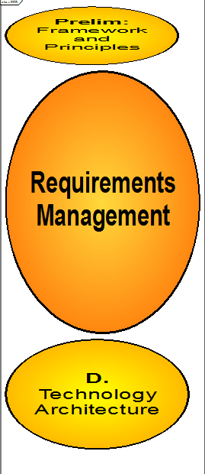

Disclaimer
Nictiz as ordering customer and Results 4 Care B.V. as subcontractor give utmost care to the reliability and timeliness of data in this DCM, Detailed Clinical Model. Errors and inaccuracies may occur. Nictiz and Results 4 Care are not responsible for damages resulting from errors or inaccuracies in the information, nor for damages arising from problems caused by, or inherent in the spreading of information via the Internet, as failures or interruptions from either errors or delays in the distribution of information or services by Nictiz or Results 4 Care, or form you to Results 4 Care by means of a website from Nictiz or Results 4 Care of by e-mail, or otherwise electronically.
Nictiz and Results 4 care do not accept responsibility for possible damage suffered as a result of the use of data, advise or ideas provided by or in name of Nictiz by way of this DCM. Nictiz does not accept responsibility for the content of information in this DCM to which or from which using a hyperlink or otherwise, is referred.

In case of contradictions in the mentioned DCM documents en files the priority of the relevant documents is stated by the most recent and highest version mentioned in the revision (version management).
In case information that is included in the electronic version of this DCM is also provided in writing, in case of textual differences the written version will determine. This applies if the version description and date of both are equal. The definitive version has priority over a concept version. A revised version has priority over a previous version.

Terms of Use
The users of the DCM specifications are EHR users, analysts and modelers, implementers, also HL7 v2/3 message and CDA developers, and for the PHR (Personal Health Record) also the patient.

The DCM is open source, so free to use, not to be changed.
Changes in the content en codes are seen upon as a infringement of copyright and is damaging for the goal of use: realisation of semantic interoperability.
You can suggest changes at DCMHelpdesk@results4care.eu

Revision suggestions will be looked at and may lead to:

- revised DCM and results if accepted
- variations of the DCM adapted on a local situation.

This is all based upon : a “common ownership” but not a “special stewardship”.

Copyrights
Apparently there is an institution who holds the copyrights of the GCS. However, it is not known at this stage which institution this is and how to obtain a licence for use.

